1.4 Length of a Plane Curve

General Idea:
Determine the length of the following curves:
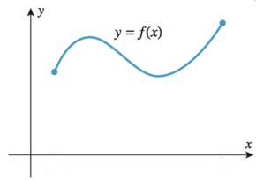
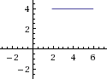

Here the length of the curve is easy to calculate. | Here the length of curve seems almost impossible to calculate!

The Specifics:
Suppose is a function with a continuous first derivative on the interval . Also suppose that a curve C is defined by the equation where .

Now, we wish to find the length of the curve C. To do this we first get an approximation by dividing into n equally spaced subintervals (with endpoints ) and approximating the curve with line segments. A picture is shown below.
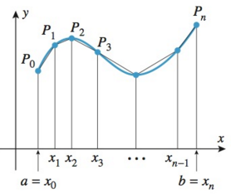
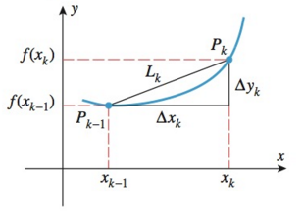

From the above picture we see that we let have coordinates . Note that the length of the kth line segment is:

We can see that the approximation gets better as n increases. This leads to the following definition:
The length of the curve C is:
Now, by the mean value theorem we know that there is a number in such that

Using this and the fact that we see that:

Now, by definition we know that the length of the curve C is given by:

Now, we notice that the limit on the right side is a definite integral! In particular,

Now we have derived the following formula.

Theorem (The Arc Length Formula): If is continuous on , then the length of the curve where is

Note: If a curve has the equation , where and is continuous on then
Example 1: Find the exact length of the curve determined by between the points and .

- Determine this by integrating with respect to x.

We see that is continuous on the interval .
Setup:
In this case we see that and , so . So the desired length is given by:

Evaluate:
Let and thus , so .
Our limits of integration become: .

- Determine this arc length by integrating with respect to y.

We see that and is continuous on the interval .
Setup:
In this case we see that and , so . So the desired length is given by:

Evaluate:
Let and thus .
Our limits of integration become:

Example 2: Set up, and evaluate using your calculator, an integral equal to the arc length of the arc of the parabola from to .

We see that is continuous on the interval .

Setup:
In this case we see that and . So the desired length is given by:

Note: we will learn to evaluate integrals like this in Chapter 3.

Definition: Suppose the curve C is given by where and is continuous on . We define the arc length function for the curve C as the function with domain given by the formula:

Note: The point is often referred to as the starting point, and in some problems we use as the interval rather than .

Note: By the fundamental theorem of calculus we see that . So, the differential of arc length is .

Note: When x is a function of y the arc length differential becomes: .

Note: When a curve C is given by a function with a continuous first derivative we call C a smooth curve. It is important to note that in this section we are working with smooth curves, but the notion of arc length can be generalized to include curves that are given by a continuous function (such a generalization does not even require that the function is differentiable!).

Example 3: Consider the function .
- Find the arc length function (simplify until no integral remains) for this function is taken to be the starting point (Hint: the radical should simplify nicely).

By the definition above we know that . So we compute.

Thus, the answer is .

- Use your answer to (a) to find the exact arc length along the curve from to

We want to find . So using our answer for part (a) we compute: .
Therefore the length of the curve on is exactly .

